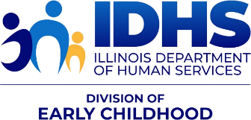
NEWS YOU CAN USE
IDHS Bureau of Home Visiting (BHV) —Information and Resources
September 15th, 2024 – FY25 Issue 2

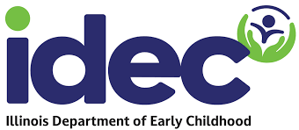
PARTICIPATION WANTED!

Support the transition to the new Illinois Department of Early Childhood (IDEC)/
Illinois is bringing all early childhood programs under one roof under one new state agency --- the Illinois Department of Early Childhood (IDEC). We are looking for parents, families, providers, and other stakeholders to participate on workgroups to hear how to make the system work better for you! Our goal is a simpler, better and fairer early childhood system in Illinois.
Members of workgroups will be expected to attend regular meetings (typically monthly) as well as 1-2 hours of pre-work or discussion in between meetings. Workgroups will start later this fall/early winter.
Please fill out this form to let us know if you are interested in serving on a workgroup: Interest form (English) & Formulario de Interés (Español)

CPRD Updates
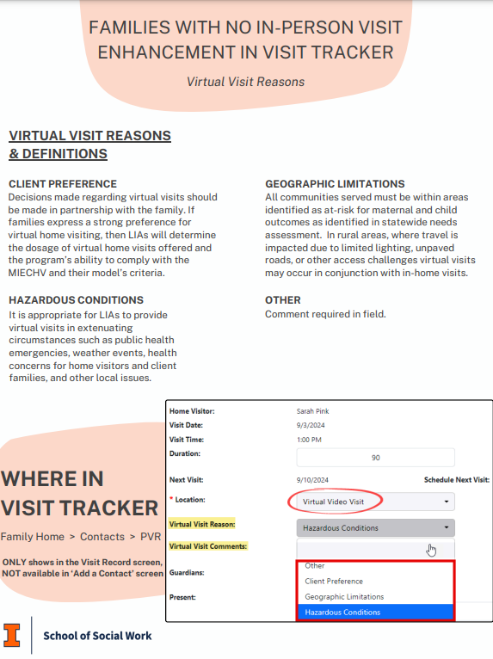
Virtual Visits
Please see the attached PDF resource (and screen shot) provided by CPRD. These resources provide information regarding the documentation of Virtual Visits in Visit Tracker.

The new virtual visit reason drop down selector is now available on Visit Tracker. Please visit https://cprd.illinois.edu/files/2024/09/No-in-person-visits.pdf to learn more about this new feature.

CPRD has New Staff!
CPRD has a new home visiting coordinator who will be focusing on the 2024 Annual Survey. They had a terrific pool of applicants for this position. Thank you for everyone who applied. They are excited to add a new staff person to help us serve the home visiting communities in Illinois.

CPRD Creates a New Resource Page
The new CPRD resource page for MIECHV and IDHS State home Visiting is now live on the CPRD website! Check it out to see training documents, recordings, and guides.

Coming Soon! Statewide Data Summary Report
This summary report shares data on MIECHV, IDHS, and MCHV Home Visiting. This will be uploaded here in the coming weeks. Check is out here!

IECMHC
Wanting to expand your understanding of Infant Early Childhood Mental Health Consultation? Check out the Illinois Model for IECMHC or the IDHS, BHV igrow page. You can also check out Infant and Early Childhood Mental Health Consultation - Illinois Cares for Kids. To locate a certified and registered IECMH professional, please check out the IL Gateways registry.

WEBINAR AND TRAINING OPPORTUNITIES

Maybe Baby: Basic of Becoming an LGBTQ+ Parent
Strengthen your work with LGBTQ+ families, connect with a community partner, and learn about a lot of great opportunities.
Maybe Baby: Basics of Becoming an LGBTQ+ Parent
Wednesday, September 18th - 6-7:30pm
Champaign Public Library - 200 W Green St, Champaign, Robeson Pavilion Rooms A/B
2024 Schedule (unitingpride.org)

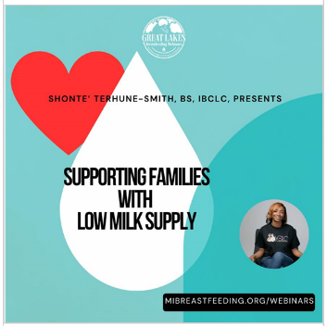
Michigan Breastfeeding Network
REGISTER
” Supporting Families with Low Milk Supply” presented by Shonte’ Terhune-Smith, BS, IBCLC. For more information, check out MIBFN or register below.

Autism Identification and Collaborative Care
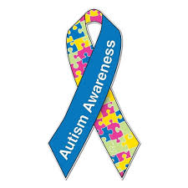
Developed by the American Academy of Pediatrics, with support from the CDC, Autism Identification and Collaborative Care aims to increase knowledge among pediatric clinicians on evidence-based practices for screening, evaluation, referral and management for autistic children and youth and their families. This 3-hour asynchronous course offers 3 CME credits and 3 MOC Part 2 points and includes practical tools to identify autism and provide collaborative care in pediatric health care settings. The course consists of the following 6 units:

- Neurodiversity, Social and Medical Models
- Characteristics, Surveillance, and Screening
- Autism Definition and Diagnosis
- Co-occurring Conditions
- Caring for Patients
- Partnering with Patients and Families

Learn more and register here. This activity has been approved for a maximum of 3.00 AMA PRA Category 1 Credit™

Health Choice is Illinois’ Medicaid Managed Care Program
The Illinois Department of Healthcare and Family Services (HFS) is holding listening sessions this September regarding HealthChoice Illinois (HCI) managed care. The attached flyer has all the details. Please help us spread the word! For more information and to register Click Here!

RESOURCES AND TOOLS


• IDPH Injury-Related Webpages - Injury and Violence Prevention, Safety Recall System, and Suicide Prevention (adolescent)
• IDPH Injury Data-Related Webpages - Injury-Related Data and Vital Statistics – Injury Deaths by County and Demographics (scroll to bottom)
• Archived webinars - injury and violence prevention webinars and suicide prevention webinars

Illinois Cares for Kids Career Campaign
The following website and messaging can be shared widely to encourage new and experienced Early Childhood Educators to find resources and credentialing information. New career opportunities will be available as well. Check it out at https://illinoiscaresforkids.careers/
https://illinoiscaresforkids.careers/home-visiting (includes a lovely brief video).

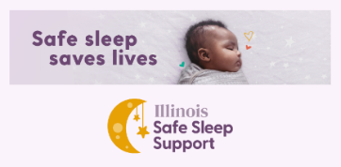
Illinois Infant Safe Sleep Support
Welcome to Illinois Safe Sleep Support, a program for families in Illinois to learn about the safest ways for their babies to sleep, get answers to their sleep safety questions, and get access to items they need to keep their babies safe.

InfantSafeSleep.Illinois.gov

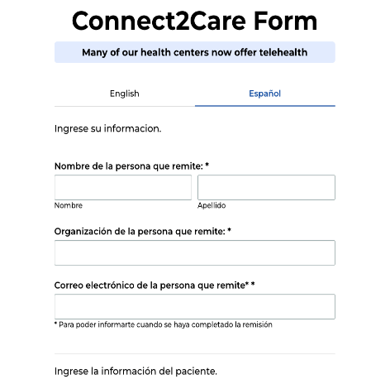
ICAN! Patient Centered Assessment of Reproductive Well Being
As a trusted source of information for your clients, you play a key role in helping to initiate conversations on contraceptive needs and desires to support your client's reproductive well-being and healthy birth spacing. ICAN! is excited to share several new and improved resources to support you to screen, counsel, and refer your clients for high-quality, person-centered, low-or-no-cost contraceptive care. If you’d like to set up a training for your team on how to use these resources or have questions, email ICAN!’s Program Director Jordan Hatcher at jhatcher@alliacnechicago.org.

Reproductive Well-Being Screening Tool – Screening clients to help normalize birth control as basic healthcare
A guide for engaging clients in respectful conversations around contraceptive needs and pregnancy planning, this job aid can be used by providers and staff working in medical and non-medical settings!

Resources for person-centered contraceptive counseling – now available in 7 languages!
Birth Control Methods Chart: Arabic, Urdu, French, Polish, Simplified Chinese, Spanish, and English. Birth Control After Baby: Arabic, Urdu, French, Polish, Simplified Chinese, Spanish, and English.

Connect2Care – Featuring 17 new health center locations including in Central and Southern Illinois!
ICAN!’s referral tool is a seamless way to connect your clients to nearby providers offering all birth control methods at low or no cost. Almost all ICAN! providers also offer primary care, including behavioral health, so clients can get their full healthcare needs met through by being connected to an ICAN! provider. The referral tool is available in English and Spanish and can be completed by anyone and takes less than 60 seconds to complete. Clients will receive text and email reminders on their chosen location and how to schedule their appointment.

Kids in Danger – Monthly Recalls

​Please click here to stay updated on all the children recalls. These are updated monthly.



DISCLAIMER: The information [including but not limited to] text, graphics, images, and any other material contained in this newsletter are for informational purposes only. Anything shared in this newsletter is not intended to be a substitute for professional health advice, diagnosis, or treatment. While all material included in this newsletter is reviewed prior to being included to confirm its relevancy, inclusion of material that is not directly developed by Illinois Department of Human Services (IDHS), Bureau of Home Visiting (BHV) means we do not own the rights to it, have not been a part of its development, and share it in “as is” form. We are not responsible for the language and design. BHV is committed to sharing information that is helpful, inclusive, shares resources and tools, and supports and challenges our growth individually and professionally.

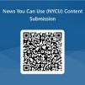
If you have content to submit for newsletter consideration, please use the new​ News You Can Use (NYCU) Content Submission Form.​ And make sure to check out the new Employee and Agency Spotlight Section – check out what your peers are doing!!​ Archived copies with attachments can be found at igrow at ​https://igrowillinois.org/miechv-bi-weekly-friday-newsletter/​

This project is supported by the Health Resources and Services Administration (HRSA) of the United States Department of Health and Human Services (HHS) under Grant Number X1046863 and Grant Number X1050299 in the total award amounts of $8,049,837 and $11,901,581, respectively, for the Maternal, Infant and Early Childhood Home Visiting Program, and 0% financed with nongovernmental sources. This information or content and conclusions are those of the author and should not be construed as the official position or policy of, nor should any endorsements be inferred by HRSA, HHS or the United States Government.

