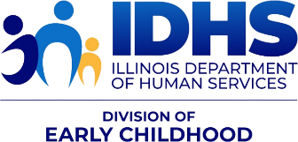
NEWS YOU CAN USE
IDHS Bureau of Home Visiting (BHV) —Information and Resources
Dual Issue October and November 2024 – FY25 Issue 3

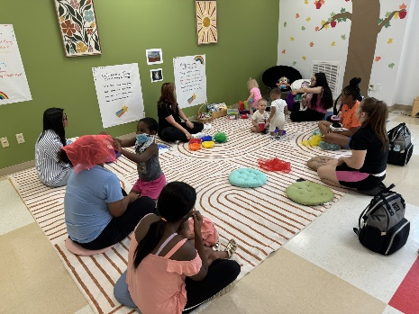
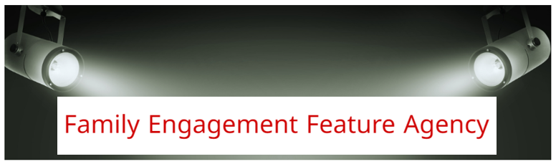
OCTOBER FEATURE: Family Outings with the Teen Family Support Program at Easterseals Serving Chicagoland and Greater Rockford
Easterseals Serving Chicagoland and Greater Rockford (ECR) is an affiliate of America's largest nonprofit health care organization, Easterseals, which has been in operation for more than 100 years. Across the country, Easterseals' affiliates are expanding access to health care, education, and employment opportunities. Our affiliate supports nearly 20,000 children and families annually in programs across the Chicagoland and Rockford regions, including a Teen Family Support Program dedicated to helping pregnant and parenting teenagers or young adults ages 13-25 develop the healthy parent-child relationships needed to foster successful child development.
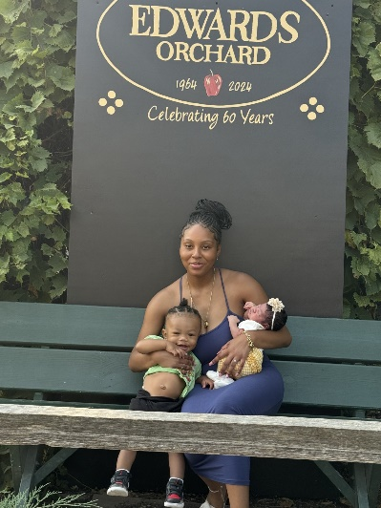
We recently polled the families we serve, and a majority requested we offer more opportunities to engage with other young parents and their children—from trips to local parks, swimming pools, and children’s farms to museum visits and other cultural enrichment activities.
Thanks to generous contributions from organizations including United Way of Rock River Valley and the Rockford Park District, we’ve been able to offer community building activities like this free of charge or at minimal cost to the young parents in our Teen Family Support Program. In September, our families and their guests joined our parent educators and doulas on a trip to Edward’s Apple Orchard, where their children learned more about nature and agriculture, developing a better sense of where our food comes from through a range of hands-on learning experiences.

We also partnered with, Heidi Holcomb, Manager of Community Partnerships at The Discovery Center Children’s Museum, to offer a parent-child interaction group where children engage in a range of developmental activities, including color mixing and sorting. The group allows our families to regularly visit the museum with their children free of charge. Moving forward, the Discovery Center Museum will provide parent-child interaction groups focused on developmentally appropriate activities for children from birth to age three.

For more information on the Teen Family Support Program at Easterseals Serving Chicagoland and Greater Rockford, please contact Kathleen Kurtz at kkurtz@eastersealschicago.org or 815.965.5069.

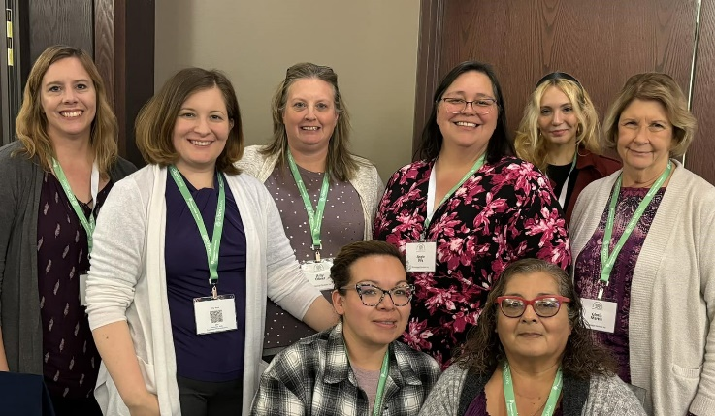
NOVEMBER FEATURE: Sinnissippi Center’s Healthy Families Illinois Program
Our IDHS Sinnissippi Centers Inc. Healthy Families Illinois program actively serves Lee, Ogle, and Whiteside counties in rural northwestern
Illinois. We have the unique privilege of being part of a community mental and behavioral health center which recognizes that Health Family America’s relational based, trauma responsive, healing model provides a foundation upon which to build lifelong mental wellbeing.

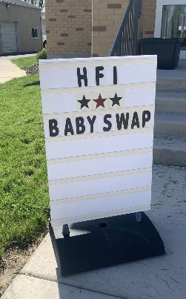
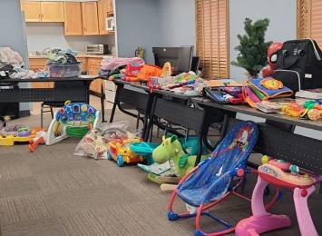
Our program prides itself on promoting the core tenets of the HFA model not only with our home visiting families but with our staff and our community at large. Our program leadership believes in the parallel process and are thrilled to be participating in the Institute for Home Visiting Workforce Development’s Learning Collaborative in an effort to better support our amazing home visiting staff that works so hard to empower our families and enhance our communities. Our program staff take an active role in the community by partnering with other early childhood champions such as the Region 47 Birth to 5 Council, the Sauk Valley STARS Early Learning Collaborative, and the Whiteside County Healthier Communities Partnership. Our program is particularly proud of our work with the Sauk Valley STARS Home Visiting Task Force which works with all of the home visiting providers in the area to promote home visiting as a whole by incorporating family voice and sharing insights on how to best support the families in our communities.

Our SCI HFI program aims to help our families build connections within their homes and communities. One popular way that we foster the connections between our families and their communities is through a semi-annual baby item and clothing swap where families can donate any gently used items their child may have outgrown and pick-up any items they may need as their child grows into the next stage of development. The swap is completely free and community donations and participation are welcome.

CONFERENCE OPPORTUNITIES

Illinois Action for Children – SAVE the DATE!!
Save the Date! 2025 Partner Plan Act Conference - May 6th – 8th, 2025
The CS3 team is excited to announce that the 2025 Partner Plan Act Conference will be held virtually from May 6th-8th, 2025! The theme will be “Equity from the Start: Interdependent Self and Community Care.” Join us for engaging discussions, insightful sessions, and networking opportunities. Be sure to check the PPA Website conference updates!
- 2025 PPA Conference – Request for Workshop Proposals
- CS3 is requesting proposals for workshop presenters for the PPA conference.
- A total of six proposals will be selected for 90-minute workshop sessions (75 minutes for presentation with 15 minutes for breaks). Selected presentations will receive a $150 honorarium.
Submit proposals to partnerplanact@actforchildren.org with the subject line “Workshop Proposal – [Workshop Title] - 2025 PPA Conference” by December 16, 2024. For additional information or questions, please contact Deb Hwang at deborah.hwang@actforchildren.org.
Conference link: https://www.partnerplanact.org/ppa/partner-plan-act-virtual-summit/
RFP link: https://www.partnerplanact.org/wp-content/uploads/2024/10/Application_RFP-2025-PPA-Conference.pdf

PARTICIPATION WANTED!

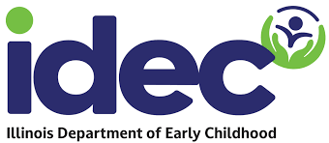
Support the transition to the new Illinois Department of Early Childhood (IDEC)/
Illinois is bringing all early childhood programs under one roof under one new state agency --- the Illinois Department of Early Childhood (IDEC). They are looking for parents, families, providers, and other stakeholders to participate on workgroups to hear how to make the system work better for you! The goal is a simpler, better and fairer early childhood system in Illinois.
Members of workgroups will be expected to attend regular meetings (typically monthly) as well as 1-2 hours of pre-work or discussion in between meetings. Workgroups will start later this fall/early winter.
Please fill out this form to let them know if you are interested in serving on a workgroup: Interest form (English) & Formulario de Interés (Español)

CPRD UPDATES


CPRD Virtual Meeting Attendance
AI BOTS: The teams at CPRD (Data Support, CQI and CI) have noticed some requests from AI Bots to join live meetings, office hours, and trainings for recording or summarizing purposes. To keep the meetings secure, interactive, and engaging, CPRD has decided to decline these requests. For training sessions, CPRD will continue to record and share the videos. However, for other meetings, CPRD believes it’s important to have live participants present, asking questions and contributing to the discussion. This reminder will be included in the CPRD meeting invitations moving forward.
Home Visiting Data Summary Information
New! IDHS-DEC BHV Home Visiting Statewide Data Summary Website Update: Check out this Infographic on the CPRD website! https://cprd.illinois.edu/files/2024/10/MIECHV_IDHS_MCHV_Infographic_20240918.pdf

RESOURCES AND TOOLS

The National Home Visiting Resource Center (NHVRC)
The National Home Visiting Resource Center (NHVRC) has released its 2024 Home Visiting Yearbook, a nationwide and state-by-state look at early childhood home visiting. The publication presents 2023 data from evidence-based and emerging home visiting models and from state agencies and the Administration for Children and Families to highlight—
- Where programs operate, the families they serve, and the families who could benefit but are not being reached
- Profiles of states, models, and Indigenous-led organizations
- Services delivered by state awardees and tribal grantees of the Maternal, Infant, and Early Childhood Home Visiting (MIECHV) Program
Users can navigate the NHVRC website to access data and download short publications, including the Yearbook Summary. The 2024 Yearbook includes virtual and in-person home visit data to reflect the field’s hybrid approach to delivering services. It also includes links to national data sources for maternal and child health indicators to offer insight into family well-being and the potential need for services.
You can find the IL profile at the state profile and the IL data table at the MIECHV data table

Illinois Cares for Kids Career Campaign
The following website and messaging can be shared widely to encourage new and experienced Early Childhood Educators to find resources and credentialing information. New career opportunities will be available as well. Check it out at https://illinoiscaresforkids.careers/
https://illinoiscaresforkids.careers/home-visiting (includes a lovely brief video).

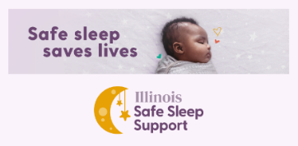
Illinois Infant Safe Sleep Support
Welcome to Illinois Safe Sleep Support, a program for families in Illinois to learn about the safest ways for their babies to sleep, get answers to their sleep safety questions, and get access to items they need to keep their babies safe.

InfantSafeSleep.Illinois.gov

New IDPH Report Shows Drop in Infant Mortality Rate
Illinois' statewide infant mortality rate decreased from 5.6 deaths per 1,000 live births in 2021, the most recent full year of data, compared to 6.5 per 1,000 in 2018. Illinois' rate of 5.6 is slightly above the national rate of 5.4.
The report also documents the historic racial disparities that have persisted nationally in the area of infant health. In Illinois, the infant mortality rate among infants born to non-Hispanic Black women is nearly three times that of infants born to White, Hispanic, and Asian women.
See more information in the News Release and Full Report.

Kids in Danger – Monthly Recalls

​Please click here to stay updated on all the children recalls. These are updated monthly.

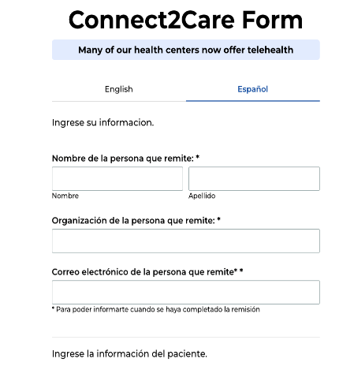
ICAN! Patient Centered Assessment of Reproductive Well Being
As a trusted source of information for your clients, you play a key role in helping to initiate conversations on contraceptive needs and desires to support your client's reproductive well-being and healthy birth spacing. ICAN! is excited to share several new and improved resources to support you to screen, counsel, and refer your clients for high-quality, person-centered, low-or-no-cost contraceptive care. If you’d like to set up a training for your team on how to use these resources or have questions, email ICAN!’s Program Director Jordan Hatcher at jhatcher@alliacnechicago.org.

Reproductive Well-Being Screening Tool – Screening clients to help normalize birth control as basic healthcare
A guide for engaging clients in respectful conversations around contraceptive needs and pregnancy planning, this job aid can be used by providers and staff working in medical and non-medical settings!

Resources for person-centered contraceptive counseling – now available in 7 languages!
Birth Control Methods Chart: Arabic, Urdu, French, Polish, Simplified Chinese, Spanish, and English. Birth Control After Baby: Arabic, Urdu, French, Polish, Simplified Chinese, Spanish, and English.

Connect2Care – Featuring 17 new health center locations including in Central and Southern Illinois!
ICAN!’s referral tool is a seamless way to connect your clients to nearby providers offering all birth control methods at low or no cost. Almost all ICAN! providers also offer primary care, including behavioral health, so clients can get their full healthcare needs met by being connected to an ICAN! provider. The referral tool is available in English and Spanish and can be completed by anyone and takes less than 60 seconds to complete. Clients will receive text and email reminders on their chosen location and how to schedule their appointment.



DISCLAIMER: The information [including but not limited to] text, graphics, images, and any other material contained in this newsletter are for informational purposes only. Anything shared in this newsletter is not intended to be a substitute for professional health advice, diagnosis, or treatment. While all material included in this newsletter is reviewed prior to being included to confirm its relevancy, inclusion of material that is not directly developed by Illinois Department of Human Services (IDHS), Bureau of Home Visiting (BHV) means we do not own the rights to it, have not been a part of its development, and share it in “as is” form. We are not responsible for the language and design. BHV is committed to sharing information that is helpful, inclusive, shares resources and tools, and supports and challenges our growth individually and professionally.

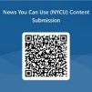
If you have content to submit for newsletter consideration, please use the new​ News You Can Use (NYCU) Content Submission Form.​ And make sure to check out the new Employee and Agency Spotlight Section – check out what your peers are doing!!​ Archived copies with attachments can be found at igrow at ​https://igrowillinois.org/miechv-bi-weekly-friday-newsletter/​

This project is supported by the Health Resources and Services Administration (HRSA) of the United States Department of Health and Human Services (HHS) under Grant Number X1046863 and Grant Number X1050299 in the total award amounts of $8,049,837 and $11,901,581, respectively, for the Maternal, Infant and Early Childhood Home Visiting Program, and 0% financed with nongovernmental sources. This information or content and conclusions are those of the author and should not be construed as the official position or policy of, nor should any endorsements be inferred by HRSA, HHS or the United States Government.

