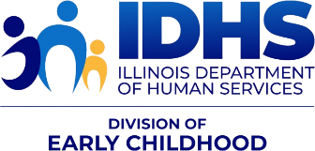
NEWS YOU CAN USE
IDHS Bureau of Home Visiting (BHV) —Information and Resources
December 2024 – FY25 Issue 4

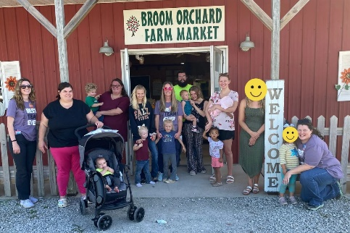
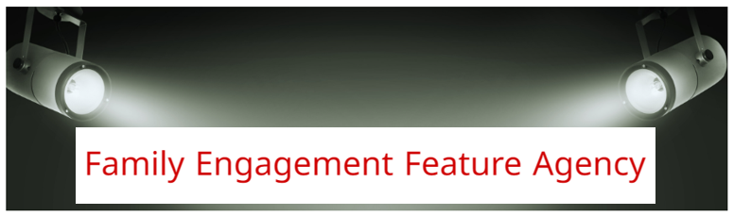
Healthy Families Macoupin County
On October 3rd, Healthy Families Macoupin County invited their families to attend Brooms Orchard for a fun afternoon and pumpkin picking. Each family in attendance received a $5.00 voucher towards for a pumpkin and a goody bag for their child. Healthy Families Macoupin County had 7 families in attendance.

The goody back included:
$5.00 pumpkin voucher, FDA Sweet Treat Safety, Safe Kids Halloween Safety Tips, Safe Kids "How to Make Your Child Seen on Halloween, Safe Kids "Check This Out Before You Go Out This Halloween, Glow stick bracelet, Paint Brush, Paints, Canvas Decorate-Your-Own Halloween Trick or Treat Bag, a fall coloring book, fun coloring sheets, animal crackers or teething crackers (depending on the age of the child), and a Save The Date for HFMC Christmas Party.

The children played, helped pick pumpkins, interacted with other HFMC families, and fed the goats.

Healthy Families is doing an Angel Tree Christmas Program for children 0-5, in collaboration with our WIC Department. We have 79 children signed up from Macoupin County at this time, but we anticipate around 100 children to be served. The Angel Tree gifts will include clothing, shoes, toys, and any item that the family has identified as a NEED that they cannot obtain if we are able to meet that need.

Great job Macoupin County! Thank you for your hard work and dedication.
Sincerely,
IDHS, BHV Team

CONFERENCE OPPORTUNITIES

Illinois Action for Children – SAVE THE DATE!!
Save the Date! 2025 Partner Plan Act Conference - May 6th – 8th, 2025

The CS3 team is excited to announce that the 2025 Partner Plan Act Conference will be held virtually from May 6th-8th, 2025! The theme will be “Equity from the Start: Interdependent Self and Community Care.” Join them for engaging discussions, insightful sessions, and networking opportunities. Be sure to check the PPA Website conference updates!
- 2025 PPA Conference – Request for Workshop Proposals
- CS3 is requesting proposals for workshop presenters for the PPA conference.
- A total of six proposals will be selected for 90-minute workshop sessions (75 minutes for presentation with 15 minutes for breaks). Selected presentations will receive a $150 honorarium.
Submit proposals to partnerplanact@actforchildren.org with the subject line “Workshop Proposal – [Workshop Title] - 2025 PPA Conference” by December 16, 2024. For additional information or questions, please contact Deb Hwang at deborah.hwang@actforchildren.org.

Conference link: https://www.partnerplanact.org/ppa/partner-plan-act-virtual-summit/
RFP link: https://www.partnerplanact.org/wp-content/uploads/2024/10/Application_RFP-2025-PPA-Conference.pdf
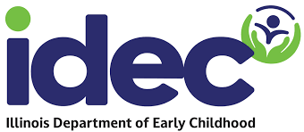
PARTICIPATION WANTED!

Support the transition to the new Illinois Department of Early Childhood (IDEC)/
Illinois is bringing all early childhood programs under one roof under one new state agency --- the Illinois Department of Early Childhood (IDEC). They are looking for parents, families, providers, and other stakeholders to participate in workgroups to hear how to make the system work better for you! The goal is a simpler, better and fairer early childhood system in Illinois.
Members of workgroups will be expected to attend regular meetings (typically monthly) as well as 1-2 hours of pre-work or discussion in between meetings. Workgroups will start later this fall/early winter.
Please fill out this form to let them know if you are interested in serving on a workgroup: Interest form (English) & Formulario de Interés (Español)

CPRD UPDATES
CPRD Resource Page
Check out the CPRD resource page to see training documents, recordings, and guides! https://cprd.illinois.edu/benchmark-resources-and-trainings-for-illinois-miechv-and-idhs-state-home-visitors/

RESOURCES, WEBINARS, AND TOOLS

Supporting Parenting Capacity in Families Recently Arriving – Webinar
Questions for the Supporting Parenting Capacity in Families Recently Arriving webinar can be submitted at rapidresponse@nationalalliancehvmodels.org. The webinar can be viewed at https://parentsasteachers.zoom.us/rec/share/crJkDXLwcWUXufDu9NmdP2ygLjZq2954mbGUj4m7-Hv7t1w4-HpQOmd9QTm3I0TK.CrJsCbAZANYQaq2I?startTime=1730923243000 .Find additional resources and future webinar registration links at https://rrvhv.earlyimpactva.org/

ICAAP – Pediatric ADHD
ICAAP is partnering with ECHO-Chicago for a series on Pediatric ADHD, beginning Thursday, January 9. For more information, review the attached flyer.

Illinois Suicide Prevention Alliance Public Awareness
The Illinois Suicide Prevention Alliance Public Awareness Subcommittee and the IDPH Office of Women’s Health and Family Services have created this infographic on adolescent suicide and suicide prevention on the Illinois Department of Public Health’s Suicide Prevention website – which you can find here. Or on the IDPH Suicide Prevention Webpage under Publications titled Suicide: Illinois Youth.

Newly Revised Early Intervention Family Guide Available
The newly revised Family Guide for the Illinois Early Intervention Program is available now! This revised guide is the culmination of several years, various committees, dozens of drafts, a long process of reviews that gathered input from a wide range of stakeholders, several parent liaisons, and a focus group that included parents who were or have been in the early intervention system. To learn more about the changes in this revision, see https://eiclearinghouse.org/blogs/newly-revised/

The hope is that this Family Guide will make it easier to incorporate it in your discussions with families during different stages of their journey in the early intervention program, not just when they first enter it. For the first time, the complete “Family Guide” is available not only in English and Spanish, but also in the following languages: Arabic, Simplified Chinese, French, Kiswahili, Polish, Russian, and Urdu.

Illinois Cares for Kids Career Campaign
The following website and messaging can be shared widely to encourage new and experienced Early Childhood Educators to find resources and credentialing information. New career opportunities will be available as well. Check it out at https://illinoiscaresforkids.careers/
https://illinoiscaresforkids.careers/home-visiting (includes a lovely brief video).

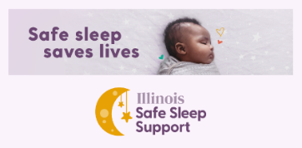
Illinois Infant Safe Sleep Support
Welcome to Illinois Safe Sleep Support, a program for families in Illinois to learn about the safest ways for their babies to sleep, get answers to their sleep safety questions, and get access to items they need to keep their babies safe.

InfantSafeSleep.Illinois.gov

New IDPH Report Shows Drop in Infant Mortality Rate
Illinois' statewide infant mortality rate decreased from 5.6 deaths per 1,000 live births in 2021, the most recent full year of data, compared to 6.5 per 1,000 in 2018. Illinois' rate of 5.6 is slightly above the national rate of 5.4.
The report also documents the historic racial disparities that have persisted nationally in the area of infant health. In Illinois, the infant mortality rate among infants born to non-Hispanic Black women is nearly three times that of infants born to White, Hispanic, and Asian women.
See more information in the News Release and Full Report.


Kids in Danger – Monthly Recalls

​Please click here to stay updated on all the children recalls.
These are updated monthly.
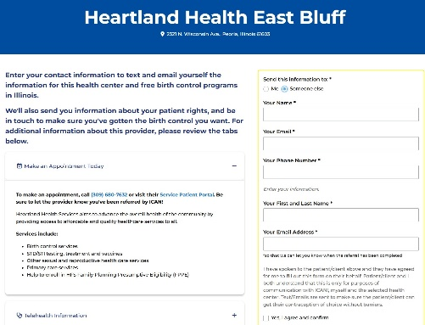

New ICAN! Resources!
Recommend a Health Center (En/Sp) – A refreshed tool with even more sites across the state!
ICAN!’s referral tool is a seamless way to connect your clients to nearby providers offering reproductive care and enrollment support in Medicaid programs. Clients will receive text and email reminders on their chosen location and how to schedule their appointment (image attached).

Know Your Rights! (En/Sp)
Print or download our newest flyer to inform patients of their right to birth control, STI, emergency contraception, and preconception care in Illinois, and quickly link to resources to understand program eligibility, birth control options, and a provider near them.

Birth control educational resources
- Birth Control Methods Chart: Arabic, Urdu, French, Polish, Simplified Chinese, Spanish, and English.
- Birth Control After Baby: Arabic, Urdu, French, Polish, Simplified Chinese, Spanish, and English.
*NEW* - Birth control zine (access folding instructions here)

Screening patients for contraceptive, preconception, or STI needs (En/Sp)
Our reproductive well-being screening tool helps guide conversations with clients and can be used by staff in both medical and non-medical settings.



DISCLAIMER: The information [including but not limited to] text, graphics, images, and any other material contained in this newsletter are for informational purposes only. Anything shared in this newsletter is not intended to be a substitute for professional health advice, diagnosis, or treatment. While all material included in this newsletter is reviewed prior to being included to confirm its relevancy, the inclusion of material that is not directly developed by Illinois Department of Human Services (IDHS), Bureau of Home Visiting (BHV) means we do not own the rights to it, have not been a part of its development, and share it in “as is” form. We are not responsible for the language and design. BHV is committed to sharing information that is helpful, inclusive, shares resources and tools, and supports and challenges our growth individually and professionally.

This project is supported by the Health Resources and Services Administration (HRSA) of the United States Department of Health and Human Services (HHS) under Grant Number X1046863 and Grant Number X1050299 in the total award amounts of $8,049,837 and $11,901,581, respectively, for the Maternal, Infant and Early Childhood Home Visiting Program, and 0% financed with nongovernmental sources. This information or content and conclusions are those of the author and should not be construed as the official position or policy of, nor should any endorsements be inferred by HRSA, HHS, or the United States Government.

